Thermal stresses
Consider a homogeneous rod AB of uniform cross section resting on a smooth horizontal surface. If the temperature of the rod is raised by $∆T$, the rod elongates an amount equal to $δ_{T}$ which is proportional to the length of the bar and the temperature change.  $$δ_{T}=αL∆T$$  $α$ is known as the coefficient of thermal expansion which is a characteristic of the material | 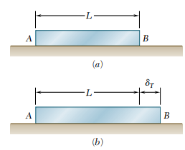
The thermal strain, $ε_{T}=\frac{δ_{T}}{L}=α∆T$
This thermal strain will not introduce any stress in the rod as it is free to expand (or contract). If the expansion (or contraction) is constrained, then only the stresses are developed due to temperature change. Then, they constitute statically indeterminate problems, which are discussed below.
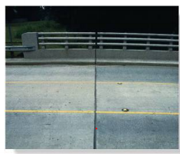 | 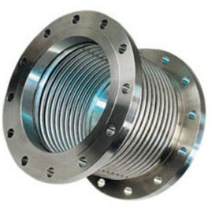
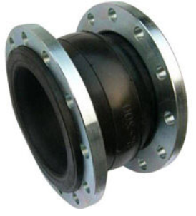 | 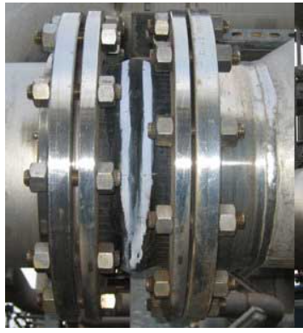

Statically indeterminate problems
The problems which cannot be solved by the static equilibrium equations alone are classified as statically indeterminate problems. The number of unknowns in such cases will be more than the number of static equilibrium equations. In such situations, we need to use additional equations considering the deformation of the material. These equations are known as compatibility equations.
Example 1  A rod of length $L=0.75 m,$ cross sectional area $A_{1}=200 {mm}^{2}$ and modulus of elasticity $E_{1}=200 GPa$ is inserted in a tube of the same length, but of cross sectional area $A_{2}=100 {mm}^{2}$ and modulus of elasticity $E_{2}=120 GPa$. If the ends are rigidly connected together and a load of $150$ $kN$ is applied as shown, determine the deformation of the tube and rod and the compressive stresses on the tube and the rode. |  | 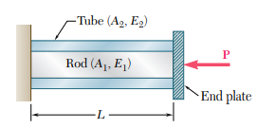
Since, the ends are connected together, the deformation happening to the tube and the rod will be the same, but the load acting on both will be different. Let the force on the rod be $P_{1}$and that on the tube be $P_{2}$. Considering the free-body diagram of the cover plate, we write the static equilibrium equation as,  $$P_{1}+P_{2}-P=0 ≪≫ P_{1}+P_{2}=150 kN$$ | 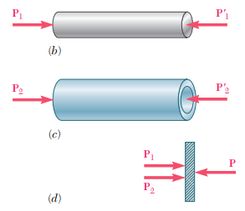
Since, there are two unknowns, we cannot solve the equation using the static equilibrium equations alone. Hence, this is a statically indeterminate problem. Let us consider the compatibility equation by considering the deformation of the rod and tube. The forces acting on the tube and rod are axial, and hence the deformation of the rode, $δ_{1}=\frac{P_{1}L}{A_{1}E_{1}}$ and that of tube $δ_{2}=\frac{P_{2}L}{A_{2}E_{2}}$. Since, both deform together, we can write, $δ_{1}=δ_{2}$ (compatibility condition)
$$\frac{P_{1}L}{A_{1}E_{1}}=\frac{P_{2}L}{A_{2}E_{2}} ≪≫ P_{1}= \left(\frac{A_{1}E_{1}}{A_{2}E_{2}}\right)P_{2}=\frac{200×{10}^{-6}×200×{10}^{9}}{100×{10}^{-6}×120×{10}^{9}}P_{2}=3.33P_{2}$$
$$∴3.33P_{2}+P_{2}=150×{10}^{3 }N$$
$$P_{2}=34642 N ≪≫ P_{1}=115358 N$$
$$∴σ_{1}=\frac{P_{1}}{A_{1}}=\frac{115358 N}{200×{10}^{-6} m^{2}}=576.8×{10}^{6}\frac{N}{m^{2}}≪≫σ_{2}=\frac{P_{2}}{A_{2}}=\frac{34642 N}{100×{10}^{-6} m^{2}}=346.4×{10}^{6}\frac{N}{m^{2}}$$
The compressive stress in rod$=576.8 MPa$
The compressive stress in tube$=346.4 MPa$
Deformation of the rod, $δ_{1}=\frac{P_{1}L}{A_{1}E_{1}}=\frac{115358 N×0.75 m}{200×{10}^{-6} m^{2}×200×{10}^{9}\frac{N}{m^{2}}}=2.16×{10}^{-3 }m$
Deformation of the rod, $δ_{2}=2.16×{10}^{-3 }m$

Example 2  A bar AB of length $L=2m$ and uniform cross section of $A=300 {mm}^{2}$ is kept between two rigid supports at $A$ and $B$ before loading. If a load $P=100 kN$ is acting at $C$which is at $L_{1}=0.75 m$from A, determine the stresses in the part $AC$ and $BC$. The modulus of elasticity of the material is $E=200 GPa.$ |  | 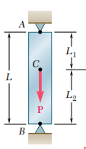
Consider the free-body diagram of the bar.  $$R_{A}+R_{B}-100 kN=0$$  $$R_{A}+R_{B}=100×{10}^{3} N$$  This is a statically indeterminate problem | 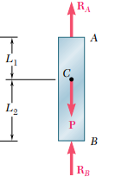 | $$D$$  $$C$$  $$C$$  $$A$$  $$R_{B}$$  $$R_{B}$$  $$R_{A}$$  $$R_{A}$$
Let us consider the free body diagram of $AC$ and $BC$. The force at $C$ on $AC$ should be$R_{A}$ downwards and that at $C$ on $BC$ should be $R_{B}$ downwards for their equilibrium. The total force at $C$ (when both parts are joined) will be $R_{A}+R_{B}$ which is equal to $P$. It can be seen from the free-body diagrams that bar $AC$ is in tension and bar $BC$ is in compression.
The elongation of $AC$,
$$δ_{AC}=\frac{R_{A}{ L}_{1}}{AE}=R_{A}\frac{0.75 m}{300×{10}^{-6}m^{2}×200×{10}^{9} N/m^{2}}=1.25×{10}^{-8}R_{A}$$
The compression of $BC$,
$$δ_{BC}=-\frac{R_{B}{ L}_{2}}{AE}={-R}_{B}\frac{1.25 m}{300×{10}^{-6}m^{2}×200×{10}^{9}\frac{N}{m^{2}}}=-2.08×{10}^{-8}R_{B}$$
Since, the bar is kept between two rigid supports, the total change in length of the bar is zero (Compatibility condition)
$$δ_{AC}+δ_{BC}=0 ≪≫ 1.25×{10}^{-8}R_{A}-2.083×{10}^{-8}R_{B}=0 ≫≫ R_{A}=1.667R_{B}$$
$$1.667R_{B}+R_{B}=100×{10}^{3} N≫≫ R_{B}=37.5×{10}^{3} N ≪≫R_{A}=62.5 ×{10}^{3} N$$
Stress on $AC$, $σ_{AC}=\frac{R_{A}}{A}=\frac{62.5 ×{10}^{3} N}{300×{10}^{-6}m^{2}}=208.3×{10}^{6} Pa (Tensile)$
Stress on $BC$, $σ_{BC}=\frac{R_{B}}{A}=\frac{37.5 ×{10}^{3} N}{300×{10}^{-6}m^{2}}=125×{10}^{6} Pa (compressive)$

We can also solve this problem in another way. It is clear that the problem is statically indeterminate because of the second support. For static equilibrium, only one support is enough. There is a redundant support in this case. Let us first remove a redundant support.
$$A$$
$$C$$
$$B_{ }$$
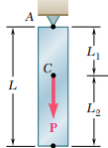  The redundant support is removed | $$A$$  $$R_{ }$$  $$P_{ }$$  $$R_{ }$$  $$C$$  $$P_{ }$$  $$B_{ }$$  $$δ$$ |  | $$δ$$  $${R'}_{ }$$  $${R'}_{ }$$
The reaction at the support A, $R=P$  Elongation of the part AC,  $$δ=\frac{PL_{1}}{AE}=\frac{100×{10}^{3}N×0.75 m}{300×{10}^{-6}m^{2}×200×{10}^{9} N/m^{2}}=1.25×{10}^{-3} m$$  $$Stress on AC=\frac{100×{10}^{3}N}{300×{10}^{-6}m^{2}}$$  $$=333.3{×10}^{6} Pa (Tensile)$$  $$Stress on BC=0$$ |  | Now, the bar is compressed with a force $R'$ at the free end so that the bar get compressed by an amount $δ$ sothat the compatibility condition of zero net deformation is satisfied.  $$δ=\frac{R'L}{AE}$$  $$1.25×{10}^{-3} m=\frac{R^{'}×2 m}{300×{10}^{-6}×200×{10}^{9} }$$  $$R^{'}=37.5×{10}^{3}N$$  $$stress on bar AB=\frac{37.5×{10}^{3}N}{300×{10}^{-6}m^{2}}$$  $$=125{×10}^{6} Pa (Compressive)$$  $Stress on AC=125{×10}^{6} Pa (Compressive)$  $Stress on BC=125{×10}^{6} Pa \left(Compressive\right)$
Net stress in part AC, $σ_{AC}=333.3{×10}^{6} Pa-125{×10}^{6} Pa =208.3 MPa (T)$
Net stress in part BC, $σ_{BC}=0-125{×10}^{6} Pa =-125{×10}^{6} Pa=125 MPa (C)$
The reaction at A, $R_{A}=R-R^{'}=100×{10}^{3}N-37.5×{10}^{3}N=62.5×{10}^{3}N$
The reaction at B, $R_{B}=0+37.5×{10}^{3}N=37.5×{10}^{3}N$

Example 3  The steel rod shown in figure has a diameter of $10 mm$. It is fixed to the wall at $A$, and before it is laded, there is a gap of $0.2 mm$ between the wall at $B’$ and the rod. Determine the reactions at $A$ and $B’$ if the rod is subjected to an axial force of $P= 20 kN$ as shown. Neglect the size of the collar at $C$. Take $E= 200 GPa$ | 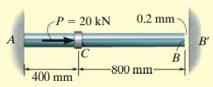
Let us find out the elongation of the bar due to the axial force $P$. When we draw the free body diagram of $AC$ and $CB$, we can see that $CB$ is not having any force. From $AC$, $R_{1}=P$  $δ=\frac{P L_{ac}}{AE}=\frac{20×{10}^{3}N×0.4 m}{\frac{π}{4}×{0.01}^{2} m^{2}×200×{10}^{9}N/m^{2}}=0.509×{10}^{-3}m=0.509 mm$ | $$P$$  $$R_{1}$$

It is given that there is a gap of $0.2 mm$ between the rod and the wall. The rod will come and touch the wall only after the elongation exceeds $0.2 mm$. Then only, there will be reaction at $B$. Since, the support is rigid, it will not allow the bar to deform further.
Let us consider the free-body diagram of the bar after it touches the support at B.  The equilibrium equation is  $R_{A}+R_{B}-P=0≪≫ R_{A}+R_{B}=20 kN$  Now, it is a statically indeterminate problem.  Consider the free-body diagram of $AC$ and $CB$. | 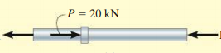  $$R_{B}$$  $$R_{A}$$  $$R_{A}$$  $$R_{B}$$  $$R_{B}$$  $$R_{A}$$
Deformation of AC, $δ_{ac}=\frac{R_{A} L_{ac}}{AE}=\frac{R_{A}×0.4 m}{\frac{π}{4}×{0.01}^{2} m^{2}×200×{10}^{9}N/m^{2}}=2.55×{10}^{-8} R_{A}$
Deformation of CB, $δ_{bc}=-\frac{R_{B} L_{cb}}{AE}=-\frac{R_{B}×0.8 m}{\frac{π}{4}×{0.01}^{2} m^{2}×200×\frac{{10}^{9}N}{m^{2}}}=-5.10×{10}^{-8} R_{B}$
Once the rod touches the support, the net deformation of the rod $0.2mm$ (compatibility condition).
$$2.55×{10}^{-8} R_{A}-5.10×{10}^{-8} R_{B}=0.2×{10}^{-3}≪≫ 2.55 R_{A}-5.1R_{B}=0.2×{10}^{5}$$

$$5.1R_{A}+{2.55R}_{A}=5.1×20×{10}^{3}+0.2×{10}^{5} ≪≫ R_{A}=15.95×{10}^{3} N ≪≫ R_{B}=4.05×{10}^{3} N$$
Before the rod touches the support at B,
$$R_{A}=20×{10}^{3} N ≪≫ R_{B}=0$$
After it touches the support at B,
$$R_{A}=15.95×{10}^{3} N ≪≫ R_{B}=4.05×{10}^{3} N$$
Another way:  If we assume that there is no support at $B$, the force $P$ will elongate the bar by an amount equal to $0.509 mm$. Now, the force $R_{B}$ will compress the bar by amount equal to $0.309 mm$  $$0.309×{10}^{-3}m=\frac{R_{B} L_{ab}}{AE}=\frac{R_{B}×1.2 m}{\frac{π}{4}×{0.01}^{2} m^{2}×200×{10}^{9}N/m^{2}}$$  $$R_{B}=4.05×{10}^{3}N$$  Reaction at A,  $$R_{A}=R_{1}-R_{2}=20×{10}^{3}-4.05×{10}^{3}N=15.95×{10}^{3}N$$ | $$0.2mm$$  $$R_{1}$$  $$P$$  $$0.509mm$$  $$R_{2}=R_{B}$$  $$R_{B}$$  $$0.309mm$$

Example 4  A bolt made of $2014-T6$ aluminium alloy ($E_{bolt}=73 GPa)$ is tightened so that it compresses a cylindrical tube made of $AM 1004-T61$ magnesium alloy ($E_{tube}=45 GPa)$. The tube has a length of $75 mm$ and an outer radius of $12.5 mm$, and it is assumed that both the inner radius of the tube and the radius of the bolt are $6.25 mm$. The washers at the top and bottom of the tube are considered to be rigid and have a negligible thickness. Initially the nut is hand tightened snugly, then using a wrench, the nut is further tightened one-half turn. If the bolt has $40$threads in $50 mm$ length, determine the stress in the bolt. | 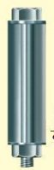  $$75 mm$$
The pitch of the bolt thread= axial advancement of bolt when it is turned one complete revolution.  $$p=\frac{50 mm}{40}=1.25 mm$$  The axial movement of the nut when it tightened one-half turn$=0.625 mm$ | 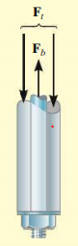
It can be seen that the tube will be in compression and the bolt will be in tension. The equilibrium equation is
$F_{bolt}-F_{tube}=0 ≪≫ F_{bolt}=F_{tube}$
This is again a statically indeterminate problem. When the nut is tightened, the tube will be compressed and the bolt will be elongated. Therefore, the distance moved by the nut will be the result of compression of tube and elongation of the bolt.
Elongation of the bolt, $δ_{bolt}=\frac{F_{bolt}×L}{A_{bolt}×E_{bolt}}=\frac{F_{bolt}×0.075 m}{π×{0.00625}^{2} m^{2}×73×{10}^{9}N/m^{2}}=8.3725×{10}^{-9 }F_{bolt}$
Compression of the tube, $δ_{tube}=\frac{F_{tube}×L}{A_{tube}×E_{tube}}=\frac{F_{tube}×0.075 m}{π×{({0.0125}^{2}-0.00625}^{2} ) m^{2}×45×{10}^{9}N/m^{2}}=4.5275×{10}^{-9 }F_{tube}$
Hence, we can write the compatibility equation as,
$$0.625×{10}^{-3}m=δ_{bolt}+δ_{tube}$$
$$0.625×{10}^{-3}m=8.3725×{10}^{-9 }F_{bolt}+4.5275×{10}^{-9 }F_{tube}$$
$$F_{bolt}=F_{tube}=48.5×{10}^{3}N$$
Stress on the bolt, $σ_{bolt}=\frac{48.5×{10}^{3}N}{π×{0.00625}^{2} m^{2}}=395.2×{10}^{6} N/m^{2}$(Tensile)
Stress on the tube, $σ_{tube}=\frac{48.5×{10}^{3}N}{π×{({0.0125}^{2}-0.00625}^{2} ) m^{2}}=131.7×{10}^{6} N/m^{2}$(Compressive)

Example 5  Determine the values of the stress in portions AC and CB of the steel bar shown when the temperature of the bar $-50℃$, knowing that a close fit exists at both rigid supports when the temperature is $+75℃$. Use the values $E=200 GPa, and ∝=6.5×{10}^{-6}/℃$ for steel. | $$774 {mm}^{2}$$  $$387 {mm}^{2}$$  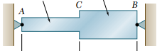  $$305 mm$$  $$305 mm$$
When the temperature drops by $125℃$, the bar contracts. But, the rigid supports will not permit the bar to contract. The free-body diagram of the bar will be as shown. The Equilibrium equation is,  $$R_{B}-R_{A}=0$$ | 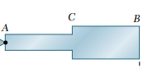  $$R_{B}$$  $$R_{A}$$
This is a statically indeterminate problem. Hence, let us assume that the support at B is removed and the temperature is decreased by $125℃$. The bar is free to contract now, and the decrease in length of the bar due to the change in temperature  ${ δ}_{t}=αL∆T=6.5×\frac{{10}^{-6}}{℃}×0.610m×125℃=0.5×{10}^{-3}m$ |  | 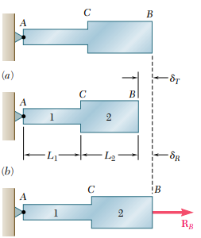  $$R_{A}=R_{B}$$
As the bar is free to contract, there will not be any stress on the bar. Also, please note that the thermal strain does not depend on the cross sectional area.
Now, a force $R_{B}$ is applied at B, which will pull the bar back to the original position, so that the net deformation is zero. That is, $R_{B}$ should produce an elongation which is equal to $0.5 mm.$ That is, the compatibility condition is
$$0.5{×10}^{-3}m=δ_{1}+δ_{2}=\frac{R_{B}×L_{1}}{A_{1}×E_{1}}+\frac{R_{B}×L_{2}}{A_{2}×E_{2}}=\frac{R_{B}×0.305m}{{387×10}^{-6} m^{2}×200×{10}^{9}N/m^{2}}+\frac{R_{B}×0.305m}{{774×10}^{-6} m^{2}×200×{10}^{9}N/m^{2}}$$
$$R_{B}=84.59×{10}^{3} N$$
The stress on AC, $σ_{AC}=\frac{84.59×{10}^{3} N}{{387×10}^{-6} m^{2}}=218.6×{10}^{6} Pa$
The stress on BC, $σ_{BC}=\frac{84.59×{10}^{3} N}{{774×10}^{-6} m^{2}}=109.3×{10}^{6} Pa$

#Exercise 1  The three $A992$ steel bars shown in figure are pin connected to a rigid member. If the applied load on the member is $15 kN$, determine the force developed in each bar. Bars $AB$ and $EF$ each have a cross sectional area of ${50 mm}^{2}$, and bar $CD$ has a cross-sectional area of ${30 mm}^{2}$. | 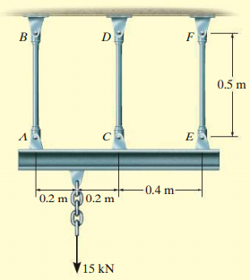
#Exercise 2  Determine the reactions at $A$ and $B$ if a load of $300 kN$ and $600$ $kN$ are acting on the bar as shown. | 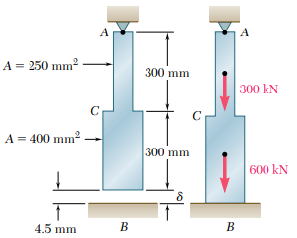
#Exercise 3  The bar shown in the figure is suspended with a gap of $1 mm$ at the bottom. If the temperature of the bar is raised by $500℃$. Determine the stress developed in the bar. | 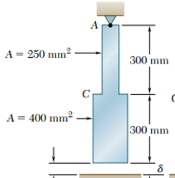
#Exercise 4  A reinforced concrete column of $2m$ height and $0.5m$ square cross section is constructed with $8$ reinforcing steel bars each of diameter $25 mm$. The column supports a compressive load P applied through a rigid bearing plate. Assuming linear elastic behavior, calculate the maximum permissible value of P if the allowable stresses in steel and concrete are $70 MPa$ and $8 MPa$ respectively. Neglect the weight of the pedestal itself, and assume $E_{steel}=200 GPa$ and $E_{concrete}=25 GPa$ | 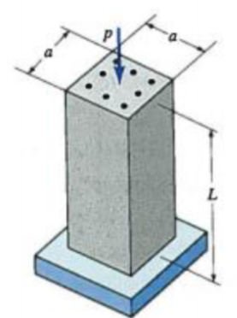

Reference:
- Mechanics of Materials, 2/e, J. M. Gere & S. P.Timoshenko, CBS Publishers.
- Mechanics of Materials, F.P. Beer & E. R. Johnston
- Engineering Mechanics of Solids, 2/e, E. P. Popov, Pearson Education Asia.
- Mechanics of Materials, 9/e, R. C. Hibbeler, Prentice Hall.

